**LEAF DISEASE DETECTION USING DEEP LEARNING & ML TECHNIQUES**

**ABTRACT**

Economy contributes the most for the productivity of the agriculture. In agricultural field, the disease in plants is more common and the detection of disease in plants has become more feasible due to the above reason. These days's plant disease detection has acquired enlarging scrutiny in surveilling crops of large and various fields. Farmers undergo significant hassles in chop and changing from one disease administer principle to a different one. We can identify or spotting the tomato leaf diseases for detection for surveillance and monitoring experts is the standard approach for detection. The plants get seriously affected if the proper control hasn't been taken and this represents the quality of the pants the production of the plants will be affected. Detection of disease through some mechanized technique and methodology is efficient and constructive because it decreases an outsized toil of surveilling in the large cultivation. In the premature phase we can detect the symptoms of the plant diseases since their first appearance on their leaves of the plants. By using this paper we can identify the algorithm which is used for image segmentation and for automated classification used for the detection of diseases of leaves in the plants. It also covers distinct disease classification methods of working which is used for the detection of diseases in plants.

The application of deep learning in plant disease recognition can avoid the disadvantages caused by artificial selection of disease spot features, make plant disease feature extraction more objective, and improve the research efficiency and technology transformation speed. This review provides the research progress of deep learning technology in the field of crop leaf disease identification in recent years. In this paper, we present the current trends and challenges for the detection of plant leaf disease using deep learning and advanced imaging techniques. We hope that this work will be a valuable resource for researchers who study the detection of plant diseases and insect pests. At the same time, we also discussed some of the current challenges and problems that need to be resolved.

**Keyword:** Plant leaf disease images, deep learning, Machine Learning, SVC, ANN, CNN, Resnet50.

**CHAPTER 1**

**INTRODUCTION**

The automated identification of plant diseases based on plant leaves is a major landmark in the field of agriculture. Moreover, the early and timely identification of plant diseases positively impacts crop yield and quality. Due to the cultivation of a large number of crop products, even an agriculturist and pathologist may often fail to identify the diseases in plants by visualizing disease-affected leaves. However, in the rural areas of developing countries, visual observation is still the primary approach of disease identification. It also requires continuous monitoring by experts. In remote areas, farmers may need to travel far to consult an expert, which is time-consuming and expensive. Automated computational systems for the detection and diagnosis of plant diseases assist farmers and agronomists with their high throughput and precision. In order to overcome the above problems, researchers have thought of several solutions. Various types of feature sets can be used in machine learning for the classification of plant diseases. Among these, the most popular feature sets are traditional handcrafted and deep-learning (DL)-based features. Pre-processing, such as image enhancement, color transformation, and segmentation, is a prerequisite before efficiently extracting features. After feature extraction, different classifiers can be used.

The occurrence of plant diseases has a negative impact on agricultural production. If plant diseases are not discovered in time, food insecurity will increase. Early detection is the basis for effective prevention and control of plant diseases, and they play a vital role in the management and decision making of agricultural production. In recent years, plant disease identification has been a crucial issue. Disease-infected plants usually show obvious marks or lesions on leaves, stems, flowers, or fruits. Generally, each disease or pest condition presents a unique visible pattern that can be used to uniquely diagnose abnormalities. Usually, the leaves of plants are the primary source for identifying plant diseases, and most of the symptoms of diseases may begin to appear on the leaves. In most cases, agricultural and forestry experts are used to identify on-site or farmers identify fruit tree diseases and pests based on experience. This method is not only subjective, but also time-consuming, laborious, and inefficient. Farmers with less experience may misjudgement and use drugs blindly during the identification process. Quality and output will also bring environmental pollution, which will cause unnecessary economic losses. To counter these challenges, research into the use of image processing techniques for plant disease recognition has become a hot research topic.

The problem of efficient plant disease protection is closely related to the problems of sustainable agriculture and climate change. Research results indicate that climate change can alter stages and rates of pathogen development; it can also modify host resistance, which leads to physiological changes of host-pathogen interactions. The situation is further complicated by the fact that, today, diseases are transferred globally more easily than ever before. New diseases can occur in places where they were previously unidentified and, inherently, where there is no local expertise to combat them.

Inexperienced pesticide usage can cause the development of long-term resistance of the pathogens, severely reducing the ability to fight back. Timely and accurate diagnosis of plant diseases is one of the pillars of precision agriculture. It is crucial to prevent unnecessary waste of financial and other resources, thus achieving healthier production, by addressing the long-term pathogen resistance development problem and mitigating the negative effects of climate change.

In this changing environment, appropriate and timely disease identification including early prevention has never been more important. There are several ways to detect plant pathologies. Some diseases do not have any visible symptoms, or the effect becomes noticeable too late to act, and in those situations, a sophisticated analysis is obligatory. However, most diseases generate some kind of manifestation in the visible spectrum, so the naked eye examination of a trained professional is the prime technique adopted in practice for plant disease detection. In order to achieve accurate plant disease diagnostics a plant pathologist should possess good observation skills so that one can identify characteristic symptoms. Variations in symptoms indicated by diseased plants may lead to an improper diagnosis since amateur gardeners and hobbyists could have more difficulties determining it than a professional plant pathologist. An automated system designed to help identify plant diseases by the plant’s appearance and visual symptoms could be of great help to amateurs in the gardening process and also trained professionals as a verification system in disease diagnostics.

Advances in computer vision present an opportunity to expand and enhance the practice of precise plant protection and extend the market of computer vision applications in the field of precision agriculture.

Exploiting common digital image processing techniques such as colour analysis and thresholding were used with the aim of detection and classification of plant diseases.

Various different approaches are currently used for detecting plant diseases and most common are artificial neural networks (ANNs) and Support Vector Machines (SVMs). They are combined with different methods of image pre-processing in favour of better feature extraction.

In machine learning and cognitive science, ANN is an information-processing paradigm that was inspired by the way biological nervous systems, such as the brain, process information. The brain is composed of a large number of highly interconnected neurons working together to solve specific problems.

An artificial neuron is a processing element with many inputs and one output. Although artificial neurons can have many outputs, only those with exactly one output will be considered. Their inputs can also take on any value between 0 and 1. Also, the neuron has weights for each input and an overall bias.

Detecting plant diseases using the deep convolutional neural network trained and fine-tuned to fit accurately to the database of a plant’s leaves that was gathered independently for diverse plant diseases. The advance and novelty of the developed model lie in its simplicity; healthy leaves and background images are in line with other classes, enabling the model to distinguish between diseased leaves and healthy ones or from the environment by using deep CNN.

Implementing the appropriate management strategies like fungicide applications, disease-specific chemical applications, and vector control through pesticide applications could lead to early information on crop health and disease detection. This could facilitate the control of diseases and improve productivity.

**CHAPTER 2**

**LITERATURE REVIEW**

**[1] Maniyath, S. R., P V, V., M, N., R, P., N, P. B., N, S., & Hebbar, R:** Crop diseases are a noteworthy risk to sustenance security, however their quick distinguishing proof stays troublesome in numerous parts of the world because of the non-attendance of the important foundation. Emergence of accurate techniques in the field of leaf-based image classification has shown impressive results. This paper makes use of Random Forest in identifying between healthy and diseased leaf from the data sets created. Our proposed paper includes various phases of implementation namely dataset creation, feature extraction, training the classifier and classification. The created datasets of diseased and healthy leaves are collectively trained under Random Forest to classify the diseased and healthy images. For extracting features of an image we use Histogram of an Oriented Gradient (HOG). Overall, using machine learning to train the large data sets available publicly gives us a clear way to detect the disease present in plants in a colossal scale. The agriculturist in provincial regions may think that it’s hard to differentiate the malady which may be available in their harvests. It's not moderate for them to go to agribusiness office and discover what the infection may be. Our principle objective is to distinguish the illness introduce in a plant by watching its morphology by picture handling and machine learning. A modern approach such as machine learning and deep learning algorithm has been employed to increase the recognition rate and the accuracy of the results. Various researches have taken place under the field of machine learning for plant disease detection and diagnosis.

**Summary**: First for any image we need to convert RGB image into gray scale image. This is done just because Hu moments shape descriptor and Haralick features can be calculated over single channel only. Therefore, it is necessary to convert RGB to gray scale before computing Hu moments and Haralick features. To calculate histogram the image first must be converted to HSV (hue, saturation and value), so we are converting RGB image to an HSV image. Finally, the main aim of our project is to detect whether it is diseased or healthy leaf with the help of a Random forest classifier which is as depicted. The objective of this algorithm is to recognize abnormalities that occur on plants in their greenhouses or natural environment. The image captured is usually taken with a plain background to eliminate occlusion. The algorithm was contrasted with other machine learning models for accuracy.

**[2] Hassan, S. M., Maji, A. K., Jasiński, M., Leonowicz, Z., & Jasińska, E.:** The timely identification and early prevention of crop diseases are essential for improving production. In this paper, deep convolutional-neural-network (CNN) models are implemented to identify and diagnose diseases in plants from their leaves, since CNNs have achieved impressive results in the field of machine vision. Standard CNN models require a large number of parameters and higher computation cost. In this paper, we replaced standard convolution with depth=separable convolution, which reduces the parameter number and computation cost. The implemented models were trained with an open dataset consisting of 14 different plant species, and 38 different categorical disease classes and healthy plant leaves. To evaluate the performance of the models, different parameters such as batch size, dropout, and different numbers of epochs were incorporated. The implemented models achieved a disease-classification accuracy rates of 98.42%, 99.11%, 97.02%, and 99.56% using InceptionV3, InceptionResNetV2, MobileNetV2, and EfficientNetB0, respectively, which were greater than that of traditional handcrafted-feature-based approaches. In comparison with other deep-learning models, the implemented model achieved better performance in terms of accuracy and it required less training time. Moreover, the MobileNetV2 architecture is compatible with mobile devices using the optimized parameter. The accuracy results in the identification of diseases showed that the deep CNN model is promising and can greatly impact the efficient identification of the diseases, and may have potential in the detection of diseases in real-time agricultural systems.

**Summary:** There are many developed methods in the detection and classification of plant diseases using diseased leaves of plants. However, there is still no efficient and effective commercial solution that can be used to identify the diseases. In our work, we used four different DL models (InceptionV3, InceptionResnetV2, MobileNetV2, EfficientNetB0) for the detection of plant diseases using healthy- and diseased-leaf images of plants. To train and test the model, we used the standard PlantVillage dataset with 53,407 images, which were all captured in laboratory conditions. This dataset consists of 38 different classes of different healthy- and diseased-leaf images of 14 different species. After splitting the dataset into 80–20 (80% of whole data for training, 20% whole images for testing), we achieved the best accuracy rate of 99.56% in EfficientNetB0 model. On average, less time was required to train the images in the MobileNetV2 and EfficientNetB0 architectures, and it took 565 and 545 s/epoch, respectively, on colored images. In comparison with other deep-learning approaches, the implemented deep-learning model has better predictive ability in terms of both accuracy and loss. The required time to train the model was much less than that of other machine-learning approaches. Moreover, the MobileNetV2 architecture is an optimized deep convolutional neural network that limits the parameter number and operations as much as possible, and can easily run on mobile devices.

**[3] Muhammad E.H. Chowdhury, Tawsifur Rahman, Amith Khandakar, Nabil Ibtehaz,:** Plants are a major source of food for the world population. Plant diseases contribute to production loss, which can be tackled with continuous monitoring. Manual plant disease monitoring is both laborious and error-prone. Early detection of plant diseases using computer vision and artificial intelligence (AI) can help to reduce the adverse effects of diseases and also helps to overcome the shortcomings of continuous human monitoring. In this study, we have extensively studied the performance of the different state-of-the-art convolutional neural networks (CNNs) classification network architectures i.e. ResNet18, MobileNet, DenseNet201, and InceptionV3 on 18,162 plain tomato leaf images to classify tomato diseases. The comparative performance of the models for the binary classification (healthy and unhealthy leaves), six-class classification (healthy and various groups of diseased leaves), and ten-class classification (healthy and various types of unhealthy leaves) are also reported. InceptionV3 showed superior performance for the binary classification using plain leaf images with an accuracy of 99.2%. DenseNet201 also outperform for six-class classification with an accuracy of 97.99%. Finally, DenseNet201 achieved an accuracy of 98.05% for ten-class classification. It can be concluded that deep architectures performed better at classifying the diseases for the three experiments. The performance of each of the experimental studies reported in this work outperforms the existing literature.

**Summary:** The stages of the process into the infinite possibilities of machine learning for agriculture applications complete with case studies. ResNet, MobileNet, DenseNet201, and InceptionV3 are examples of state-of-the-art pre-trained CNN models that do an excellent work of classifying diseases from plant leaf images. When compared to other architectures, the DenseNet201 was found to be better at extracting discriminative features from images. The trained models can be used to detect plant diseases early and automatically. As a result, preventive actions can be adopted faster. This research could help with early and automated disease detection in tomato crops, due to the use of cutting-edge technology like smartphones, drone cameras, and robotic platforms. The proposed structure can be combined with a feedback system that provides appropriate insights, treatments, disease prevention, and control techniques, resulting in improved crop yields.

**[4] Zhang, Y., Song, C., & Zhang., D.** To improve the recognition model accuracy of crop disease leaves and locating diseased leaves, this paper proposes an improved Faster RCNN to detect healthy tomato leaves and four diseases: powdery mildew, blight, leaf mold fungus and ToMV. First, we use a depth residual network to replace VGG16 for image feature extraction so we can obtain deeper disease features. Second, the k-means clustering algorithm is used to cluster the bounding boxes. We improve the anchoring according to the clustering results. The improved anchor frame tends toward the real bounding box of the dataset. Finally, we carry out a k-means experiment with three kinds of different feature extraction networks. The experimental results show that the improved method for crop leaf disease detection had 2.71% higher recognition accuracy and a faster detection speed than the original Faster RCNN. Crop disease detection is the basis of crop disease prevention to guarantee crop quality. Traditional detection methods for crop disease mainly depend on manual observation and consequently lead to low detection efficiency and poor reliability. Farmers lack professional knowledge, and agricultural experts cannot serve the field at all times so that they miss the best time for prevention

**Summary:** Faster RCNN algorithm to detect diseased tomato leaves, which can both recognize tomato diseases and detect tomato leaf locations. To make the anchors in the algorithm closer to the ground truth of our dataset, we use the k-means algorithm to cluster the bounding boxes of tomato disease images and improve the anchors based on the results. We selected ResNet101 to replace VGG16 for feature extraction, which can extract the deep features of tomato disease. The experimental results show that our method can effectively detect and recognize tomato diseases and has higher detection accuracy than the original Faster RCNN. However, the dataset is laboratory data, so only a single leaf disease in the image can be detected. Future works will include images of natural plants that should be collected for detection. In addition, tomato diseases have other disease characteristics, such as fruits and stems. Some diseases are a combination of these characteristics. Future works should combine these factors to carry out multifaceted diagnoses, which will help the development of smart agriculture.

**SYSTEM ANALYSIS & FEASIBILITY STUDY**

**Existing Method:**

This model emphasizes an existing method that which is designed using the some of the algorithms of deep learning. Here the process is performed using the machine learning, which is one of the transfer learning methods, but this could not get the high accuracy.

**Disadvantages:**

• Less feature compatibility

• Low accuracy

**Proposed System:**

In purposed method we are performing the classification of either the Plant Leaf Disease identification using Convolution Neural Network (CNN) of deep learning along with the machine learning methods. As image analysis based approaches for Leaf Disease detection. Hence, proper classification is important for the Leaf disease that which will be possible by using our proposed method. Block diagram of proposed method is shown below.

**Block Diagram:**

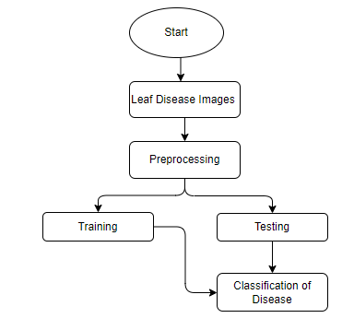

**Fig 1. Block diagram of proposed method**

**ARCHITECTURE**

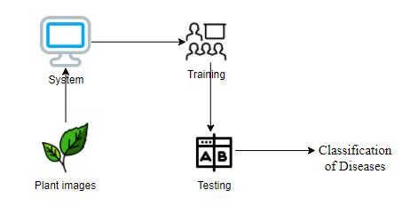

**METHODOLOGY AND ALGORITHMS:**

**1. Convolutional Neural Network**

**Step1: convolutional operation**

The first building block in our plan of attack is convolution operation. In this step, we will touch on feature detectors, which basically serve as the neural network's filters. We will also discuss feature maps, learning the parameters of such maps, how patterns are detected, the layers of detection, and how the findings are mapped out.

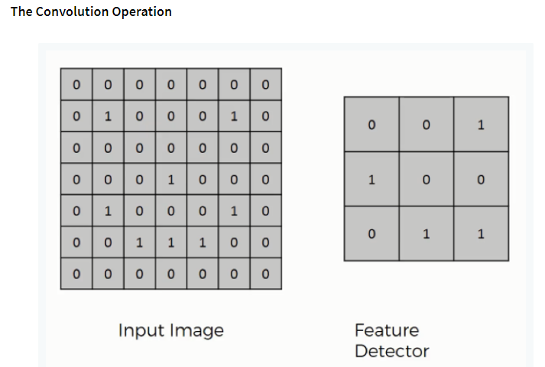

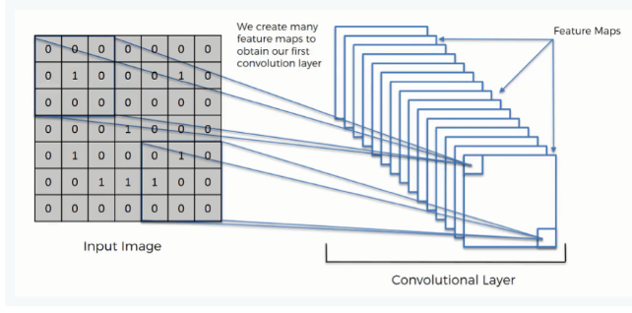

**Step (1b): ReLU Layer**

The second part of this step will involve the Rectified Linear Unit or Relook. We will cover Relook layers and explore how linearity functions in the context of Convolutional Neural Networks.

Not necessary for understanding CNN's, but there's no harm in a quick lesson to improve your skills.

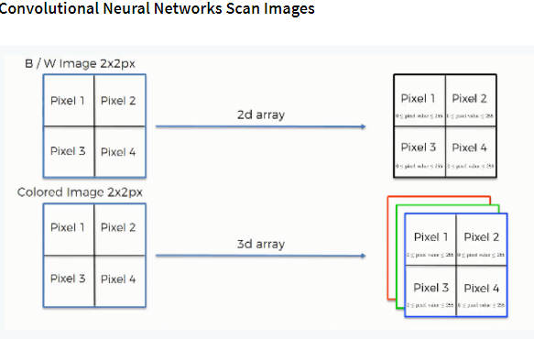

**Step 2: Conv2D**

Keras Conv2D is 2D Convolution Layer; this layer creates a convolution kernel that is wind with layers input which helps produce a tensor of outputs.

Kernel: In image processing kernel is a convolution matrix or masks which can be used for blurring, sharpening, embossing, edge detection, and more by doing a convolution between a kernel and an image

**Step 3: Flattening**

This will be a brief breakdown of the flattening process and how we move from pooled to flattened layers when working with Convolutional Neural Networks.

**Step 4: Full Connection**

In this part, everything that we covered throughout the section will be merged together. By learning this, you'll get to envision a fuller picture of how Convolutional Neural Networks operate and how the "neurons" that are finally produced learn the classification of images.

**Summary**

In the end, we'll wrap everything up and give a quick recap of the concept covered in the section. If you feel like it will do you any benefit (and it probably will), you should check out the extra tutorial in which Softmax and Cross-Entropy are covered. It's not mandatory for the course, but you will likely come across these concepts when working with Convolutional Neural Networks and it will do you a lot of good to be familiar with them.

**Convolutional neural network (CNN):**

A convolutional neural network consists of an input layer, hidden layers and an output layer. In any feed-forward neural network, any middle layers are called hidden because their inputs and outputs are masked by the activation function and final convolution.

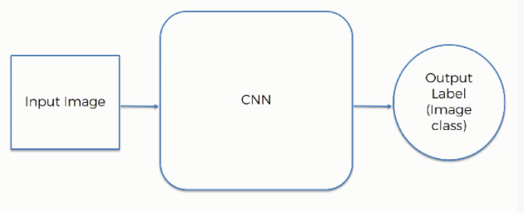

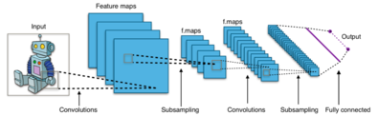

**Fig 2. CNN Architecture**

**Artificial Neural Network (ANN):**

ANN architecture is based on the structure and function of the biological neural network. Similar to neurons in the brain, ANN also consists of neurons which are arranged in various layers. Feed forward neural network is a popular neural network which consists of an input layer to receive the external data to perform pattern recognition, an output layer which gives the problem solution, and a hidden layer is an intermediate layer which separates the other layers. The adjacent neurons from the input layer to output layer are connected through acyclic arcs. The ANN uses a training algorithm to learn the datasets which modifies the neuron weights depending on the error rate between target and actual output. In general, ANN uses the back propagation algorithm as a training algorithm to learn the datasets. The general structure of ANN is shown in Fig.

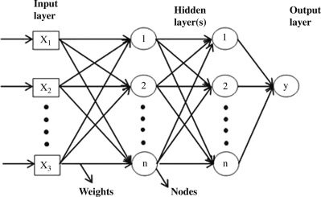

**ResNet50:**

ResNet50 is a convolutional neural network which has a depth of 50 layers. It was build and trained by Kaiming He, Xiangyu Zhang, Shaoqing Ren, and Jian Sun in their 2015 and you can access the model performance results on their paper, titled Deep Residual Learning for Image Recognition. This model is also trained on more than 1 million images from the ImageNet database. Just like VGG-19, it can classify up to 1000 objects and the network was trained on 224x224 pixels colored images. Here is brief info about its size and performance: 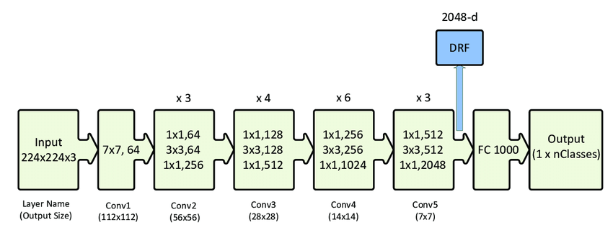

**Fig 5. ResNet50 Architecture**

To sum up, residual network or ResNet was a major innovation that has changed the training of deep convolutional neural networks for tasks related to computer vision. While the original Resnet had 34 layers and used 2-layer blocks, other advanced variants such as the Resnet50 made the use of 3-layer bottleneck blocks to ensure improved accuracy and lesser training time. Keras is a deep learning API that is popular due to the simplicity of building models using it. Keras comes with several pre-trained models, including Resnet50, that anyone can use for their experiments. Therefore, building a residual network in Keras for computer vision tasks like image classification is relatively simple. You only need to follow a few simple steps.

**Support vector machine (SVM):**

Generally, Support Vector Machines is considered to be a classification approach, it but can be employed in both types of classification and regression problems. It can easily handle multiple continuous and categorical variables. SVM constructs a Hyperplane in multidimensional space to separate different classes. SVM generates optimal Hyperplane in an iterative manner, which is used to minimize an error. The core idea of SVM is to find a maximum marginal Hyperplane (MMH) that best divides the dataset into classes.

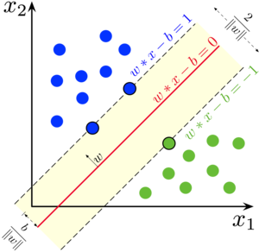

**Support Vectors**

Support vectors are the data points, which are closest to the Hyperplane. These points will define the separating line better by calculating margins. These points are more relevant to the construction of the classifier.

**Hyperplane**

A Hyperplane is a decision plane which separates between a set of objects having different class memberships.

**Margin**

A margin is a gap between the two lines on the closest class points. This is calculated as the perpendicular distance from the line to support vectors or closest points. If the margin is larger in between the classes, then it is considered a good margin, a smaller margin is a bad margin.

The main objective is to segregate the given dataset in the best possible way. The distance between the either nearest points is known as the margin. The objective is to select a Hyperplane with the maximum possible margin between support vectors in the given dataset. SVM searches for the maximum marginal Hyperplane in the following steps:

Generate Hyperplane which segregates the classes in the best way. Left-hand side figure showing three Hyperplane black, blue and orange. Here, the blue and orange have higher classification error, but the black is separating the two classes correctly.

Select the right Hyperplane with the maximum segregation from the either nearest data points as shown in the right-hand side figure.

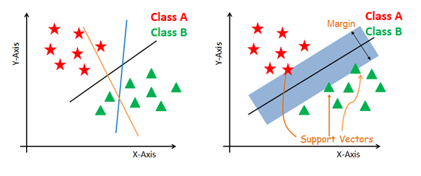

**SVM Kernels**

The SVM algorithm is implemented in practice using a kernel. A kernel transforms an input data space into the required form. SVM uses a technique called the kernel trick. Here, the kernel takes a low-dimensional input space and transforms it into a higher dimensional space. In other words, you can say that it converts non separable problem to separable problems by adding more dimension to it. It is most useful in non-linear separation problem. Kernel trick helps you to build a more accurate classifier.

The main advantage of SVM is that it can be used for both classification and regression problems. SVM draws a decision boundary which is a Hyperplane between any two classes in order to separate them or classify them. SVM also used in Object Detection and image classification.

**Polynomial Kernel**: A polynomial kernel is a more generalized form of the linear kernel. The polynomial kernel can distinguish curved or nonlinear input space.

**SOFTWARE DEVELOPMENT LIFE CYCLE – SDLC:**

In our project we use waterfall model as our software development cycle because of its step-by-step procedure while implementing.

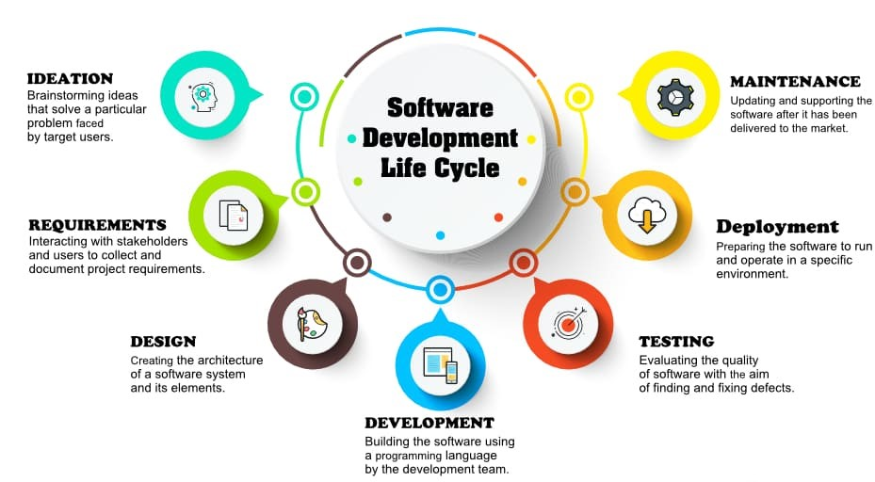

**Fig 3**: Waterfall Model

* **Requirement Gathering and analysis** − all possible requirements of the system to be developed are captured in this phase and documented in a requirement specification document.
* **System Design** − the requirement specifications from first phase are studied in this phase and the system design is prepared. This system design helps in specifying hardware and system requirements and helps in defining the overall system architecture.
* **Implementation** − with inputs from the system design, the system is first developed in small programs called units, which are integrated in the next phase. Each unit is developed and tested for its functionality, which is referred to as Unit Testing.
* **Integration and Testing** − All the units developed in the implementation phase are integrated into a system after testing of each unit. Post integration the entire system is tested for any faults and failures.
* **Deployment of system** − Once the functional and non-functional testing is done; the product is deployed in the customer environment or released into the market.
* **Maintenance** − There are some issues which come up in the client environment. To fix those issues, patches are released. Also, to enhance the product some better versions are released. Maintenance is done to deliver these changes in the customer environment.

**FEASIBILITY STUDY**

The feasibility of the project is analysed in this phase and business proposal is put forth with a very general plan for the project and some cost estimates. During system analysis the feasibility study of the proposed system is to be carried out. This is to ensure that the proposed system is not a burden to the company. For feasibility analysis, some understanding of the major requirements for the system is essential.

Three key considerations involved in the feasibility analysis are

* ECONOMICAL FEASIBILITY
* TECHNICAL FEASIBILITY
* SOCIAL FEASIBILITY

**Economic feasibility:**

This study is carried out to check the economic impact that the system will have on the organization. The amount of fund that the company can pour into the research and development of the system is limited. The expenditures must be justified. Thus, the developed system as well within the budget and this was achieved because most of the technologies used are freely available. Only the customized products had to be purchased. Technical feasibility:

This study is carried out to check the technical feasibility, that is, the technical requirements of the system. Any system developed must not have a high demand on the available technical resources. This will lead to high demands on the available technical resources. This will lead to high demands being placed on the client. The developed system must have a modest requirement, as only minimal or null changes are required for implementing this system.

**Social feasibility:**

The aspect of study is to check the level of acceptance of the system by the user. This includes the process of training the user to use the system efficiently. The user must not feel threatened by the system, instead must accept it as a necessity. The level of acceptance by the users solely depends on the methods that are employed to educate the user about the system and to make him familiar with it. His level of confidence must be raised so that he is also able to make some constructive criticism, which is welcomed, as he is the final user of the system.

**SYSTEM REQUIREMENTS SPECIFICATION**

**Functional and non-functional requirements:**

Requirement’s analysis is very critical process that enables the success of a system or software project to be assessed. Requirements are generally split into two types: Functional and non-functional requirements.

**Functional Requirements**: These are the requirements that the end user specifically demands as basic facilities that the system should offer. All these functionalities need to be necessarily incorporated into the system as a part of the contract. These are represented or stated in the form of input to be given to the system, the operation performed and the output expected. They are basically the requirements stated by the user which one can see directly in the final product, unlike the non-functional requirements.

Examples of functional requirements:

1. Authentication of user whenever he/she logs into the system
2. System shutdown in case of a cyber-attack
3. A verification email is sent to user whenever he/she register for the first time on some software system.

**Non-functional requirements**: These are basically the quality constraints that the system must satisfy according to the project contract. The priority or extent to which these factors are implemented varies from one project to other. They are also called non-behavioral requirements.  
They basically deal with issues like:

* Portability
* Security
* Maintainability
* Reliability
* Scalability
* Performance
* Reusability
* Flexibility

Examples of non-functional requirements:

1. Emails should be sent with a latency of no greater than 12 hours from such an activity.
2. The processing of each request should be done within 10 seconds
3. The site should load in 3 seconds whenever of simultaneous users are > 10000

**SYSTEM SPECIFICATIONS:**

# **H/W Specifications:**

# Processor : I5/Intel Processor

# RAM : 8GB (min)

* Hard Disk : 128 GB

**S/W Specifications:**

* Operating System : Windows 10
* Server-side Script : Python 3.6
* IDE : PyCharm, Jupyter notebook
* Libraries Used : Numpy, IO, OS, Flask, Keras, pandas, tensorflow

**SYSTEM DESIGN:**

## Input Design:

In an information system, input is the raw data that is processed to produce output. During the input design, the developers must consider the input devices such as PC, MICR, OMR, etc.

Therefore, the quality of system input determines the quality of system output. Well-designed input forms and screens have following properties −

* It should serve specific purpose effectively such as storing, recording, and retrieving the information.
* It ensures proper completion with accuracy.
* It should be easy to fill and straightforward.
* It should focus on user’s attention, consistency, and simplicity.
* All these objectives are obtained using the knowledge of basic design principles regarding −
  + What are the inputs needed for the system?
  + How end users respond to different elements of forms and screens.

### Objectives for Input Design:

The objectives of input design are

* To design data entry and input procedures
* To reduce input volume
* To design source documents for data capture or devise other data capture methods
* To design input data records, data entry screens, user interface screens, etc.
* To use validation checks and develop effective input controls.

**Output Design:**

The design of output is the most important task of any system. During output design, developers identify the type of outputs needed, and consider the necessary output controls and prototype report layouts.

### Objectives of Output Design:

The objectives of input design are:

* To develop output design that serves the intended purpose and eliminates the production of unwanted output.
* To develop the output design that meets the end user’s requirements.
* To deliver the appropriate quantity of output.
* To form the output in appropriate format and direct it to the right person.
* To make the output available on time for making good decisions.

**MODULES:**

**System**

**User**

**1. System:**

1.1 Create Dataset:

The dataset containing images of the plant disease classification images with the Plant health or not i.e., normal are to be classified is split into training and testing dataset with the test size of 30-20%.

1.2 Pre-processing:

Resizing and reshaping the images into appropriate format to train our model.

1.3 Training:

Use the pre-processed training dataset is used to train our model using CNN Deep learning and machine learning algorithms along with Resnet50 transfer learning methods.

1.4 Classification:

The results of our model are display of plant disease classification images are either with different labels

**2. User:**

2.1 Upload Image

The user has to upload an image which needs to be classified.

2.2 View Results

The classified image results are viewed by user.

**UML DIAGRAMS**

UML stands for Unified Modelling Language. UML is a standardized general-purpose modelling language in the field of object-oriented software engineering. The standard is managed, and was created by, the Object Management Group.

The goal is for UML to become a common language for creating models of object-oriented computer software. In its current form UML is comprised of two major components: a Meta-model and a notation. In the future, some form of method or process may also be added to; or associated with, UML.

The Unified Modelling Language is a standard language for specifying, Visualization, Constructing and documenting the artifacts of software system, as well as for business modelling and other non-software systems.

The UML represents a collection of best engineering practices that have proven successful in the modelling of large and complex systems.

The UML is a very important part of developing objects-oriented software and the software development process. The UML uses mostly graphical notations to express the design of software projects.

**GOALS:**

The Primary goals in the design of the UML are as follows:

1. Provide users a ready-to-use, expressive visual modelling Language so that they can develop and exchange meaningful models.
2. Provide extendibility and specialization mechanisms to extend the core concepts.
3. Be independent of particular programming languages and development process.
4. Provide a formal basis for understanding the modelling language.
5. Encourage the growth of OO tools market.
6. Support higher level development concepts such as collaborations, frameworks, patterns and components.
7. Integrate best practices.

**USE CASE DIAGRAM**

* A use case diagram in the Unified Modeling Language (UML) is a type of behavioral diagram defined by and created from a Use-case analysis.
* Its purpose is to present a graphical overview of the functionality provided by a system in terms of actors, their goals (represented as use cases), and any dependencies between those use cases.
* The main purpose of a use case diagram is to show what system functions are performed for which actor. Roles of the actors in the system can be depicted.

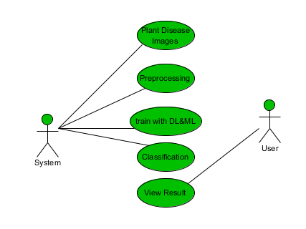

**CLASS DIAGRAM**

In software engineering, a class diagram in the Unified Modeling Language (UML) is a type of static structure diagram that describes the structure of a system by showing the system's classes, their attributes, operations (or methods), and the relationships among the classes. It explains which class contains information

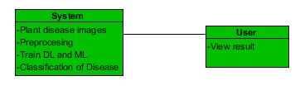

**SEQUENCE DIAGRAM**

* A sequence diagram in Unified Modeling Language (UML) is a kind of interaction diagram that shows how processes operate with one another and in what order.
* It is a construct of a Message Sequence Chart. Sequence diagrams are sometimes called event diagrams, event scenarios, and timing diagrams

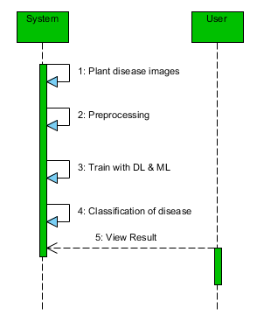

**COLLABORATION DIAGRAM:**

In collaboration diagram the method call sequence is indicated by some numbering technique as shown below. The number indicates how the methods are called one after another. We have taken the same order management system to describe the collaboration diagram. The method calls are similar to that of a sequence diagram. But the difference is that the sequence diagram does not describe the object organization whereas the collaboration diagram shows the object organization.

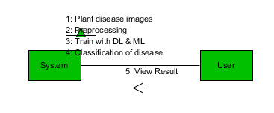

**DEPLOYMENT DIAGRAM**

Deployment diagram represents the deployment view of a system. It is related to the component diagram. Because the components are deployed using the deployment diagrams. A deployment diagram consists of nodes. Nodes are nothing but physical hardware’s used to deploy the application.

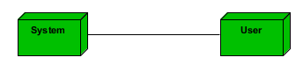

**ACTIVITY DIAGRAM:**

Activity diagrams are graphical representations of workflows of stepwise activities and actions with support for choice, iteration and concurrency. In the Unified Modeling Language, activity diagrams can be used to describe the business and operational step-by-step workflows of components in a system. An activity diagram shows the overall flow of control.

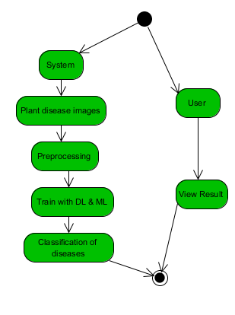

**COMPONENT DIAGRAM**:

A component diagram, also known as a UML component diagram, describes the organization and wiring of the physical **c**omponents in a system. Component diagrams are often drawn to help model implementation details and double-check that every aspect of the system's required function is covered by planned development.

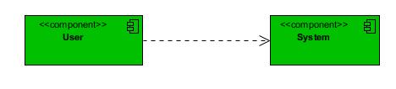

**ER DIAGRAM:**

An Entity–relationship model (ER model) describes the structure of a database with the help of a diagram, which is known as Entity Relationship Diagram (ER Diagram). An ER model is a design or blueprint of a database that can later be implemented as a database. The main components of E-R model are: entity set and relationship set.

An ER diagram shows the relationship among entity sets. An entity set is a group of similar entities and these entities can have attributes. In terms of DBMS, an entity is a table or attribute of a table in database, so by showing relationship among tables and their attributes, ER diagram shows the complete logical structure of a database. Let’s have a look at a simple ER diagram to understand this concept.

# 

**DFD DIAGRAM:**

A Data Flow Diagram (DFD) is a traditional way to visualize the information flows within a system. A neat and clear DFD can depict a good amount of the system requirements graphically. It can be manual, automated, or a combination of both. It shows how information enters and leaves the system, what changes the information and where information is stored. The purpose of a DFD is to show the scope and boundaries of a system as a whole. It may be used as a communications tool between a systems analyst and any person who plays a part in the system that acts as the starting point for redesigning a system.

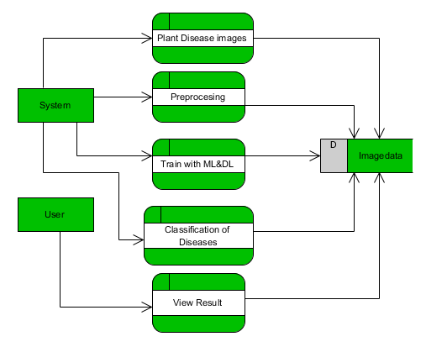

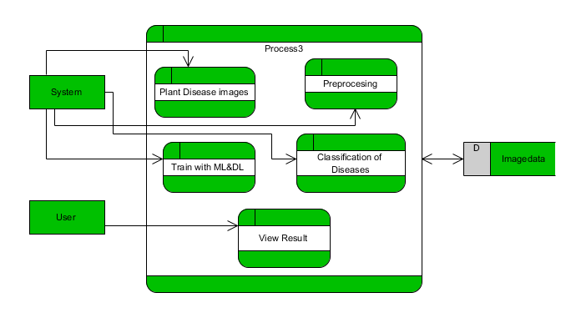

**OUTPUT SCREEN SHOTS WITH DESCRIPTION.**

**Home:** In our project, we are classifying the presence of Plant Leaf Diseases Classification, with the help of deep learning and machine learning.

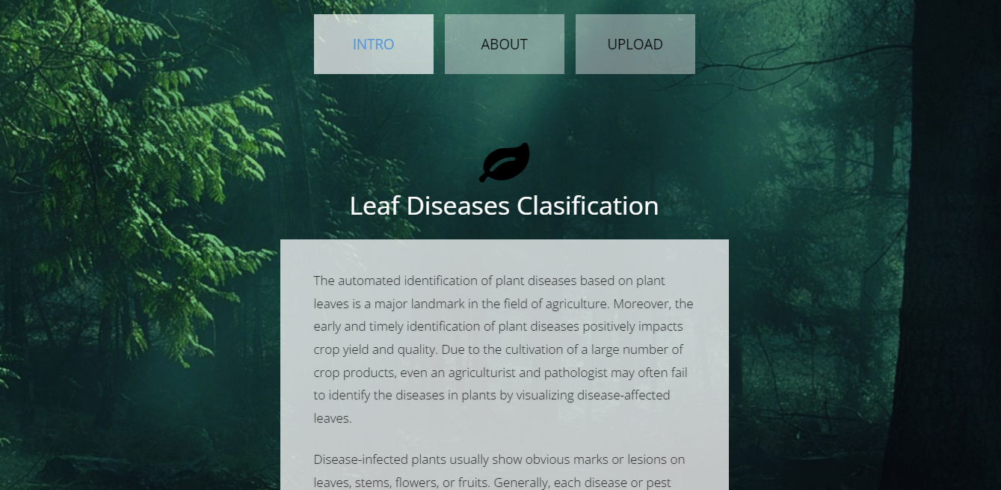

**Fig1:** Home

**About Project:** Here the user will get a breif idea about the project.

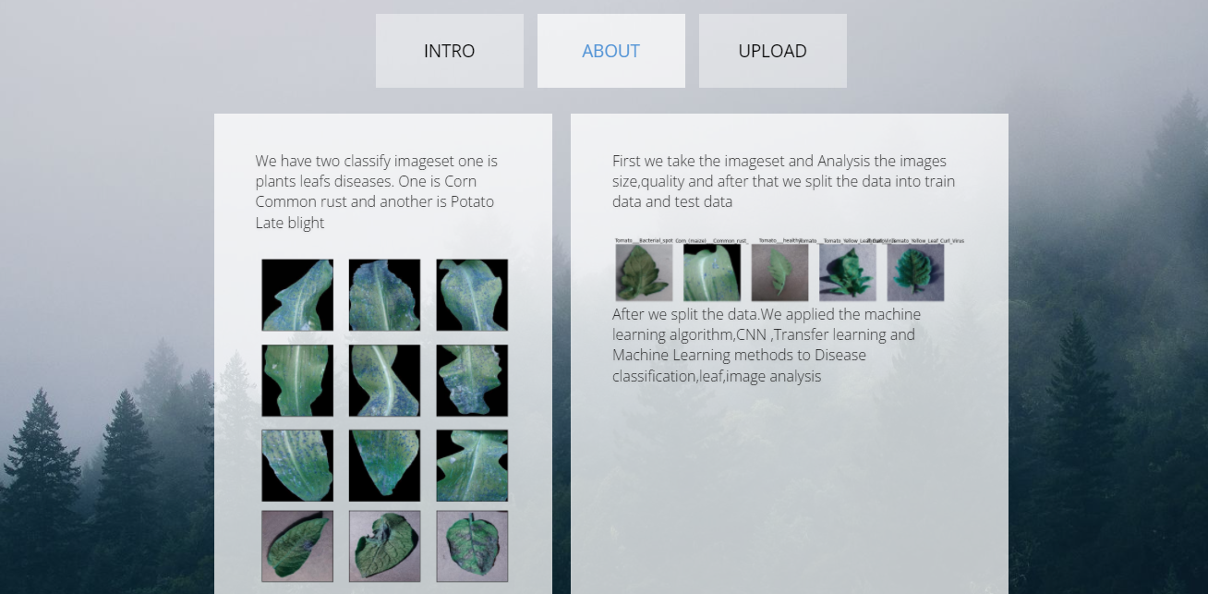

**Fig2**: About Project

**Upload Image:**

Here the images can be uploaded those which are to be classified.

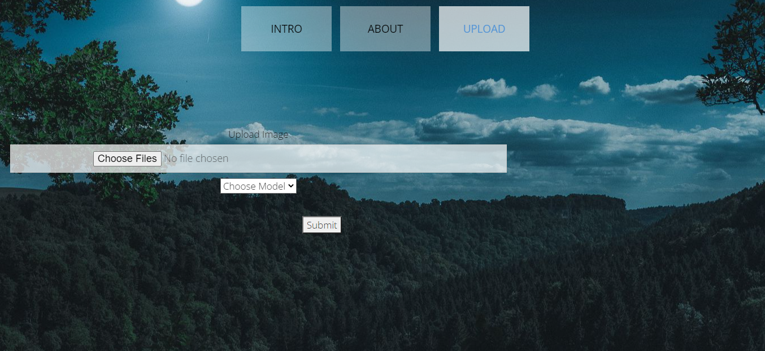

**Fig3**: Image Uploading

**Model choosing:**

Here the model can be selected, by which the image is to be classified.

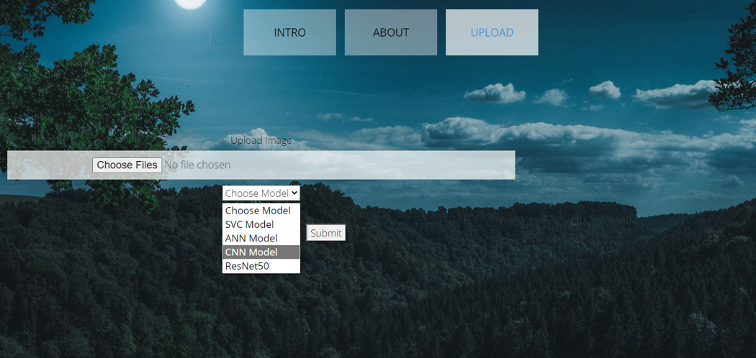

**Fig4:** Model choosing

**Classified output:**

The uploaded image is classified as the Corn_(maize)___Cercospora_leaf_spot Gray_leaf_spot.

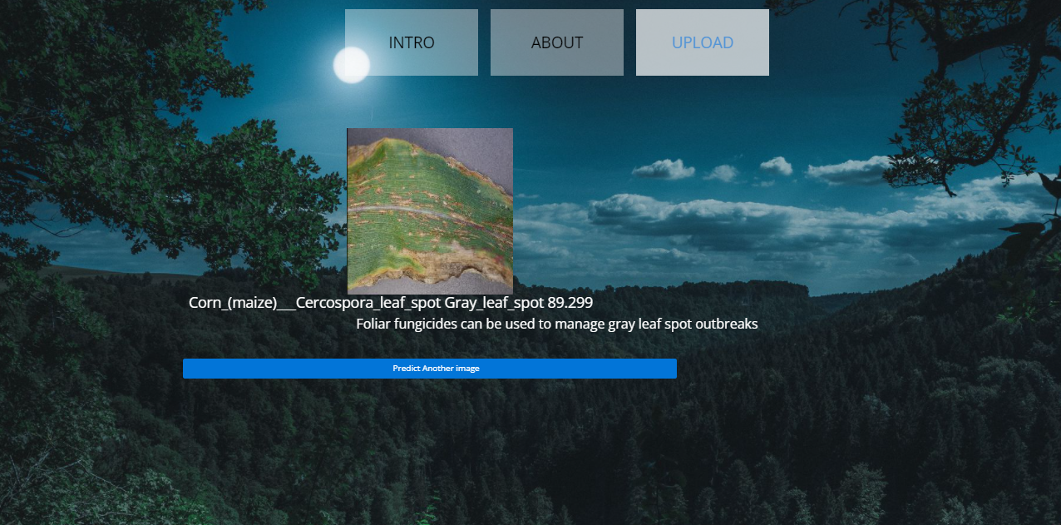

**Fig5**: Classified output

**Classified output:**

The uploaded image is classified as the Corn_(maize)___Common_rust_.

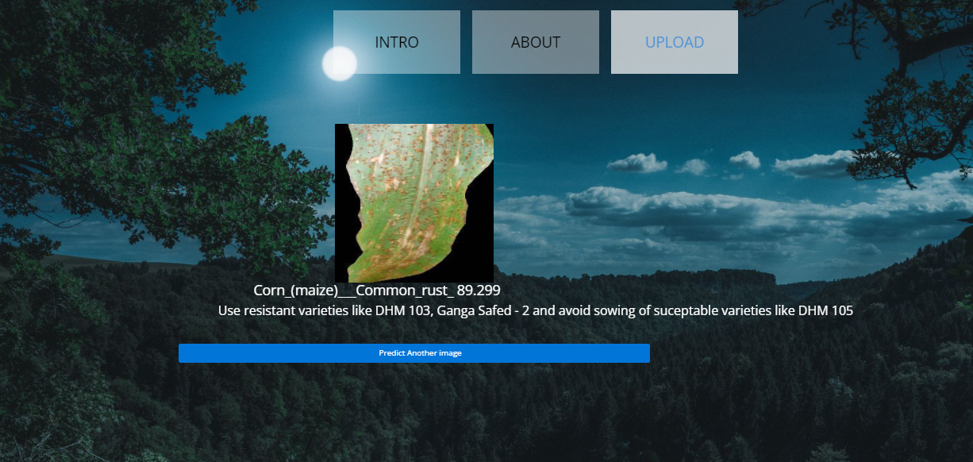

**Fig5**: Classified output

**Classified output:**

The uploaded image is classified as the Corn_(maize)___healthy.

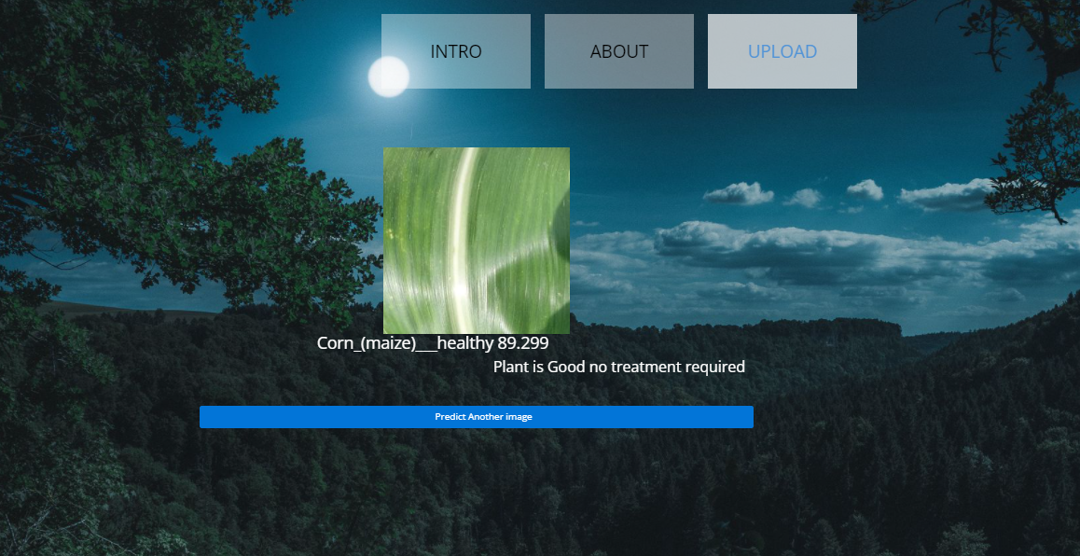

**Fig5**: Classified output

**Classified output:**

The uploaded image is classified as the Corn_(maize)___Northern_Leaf_Blight.

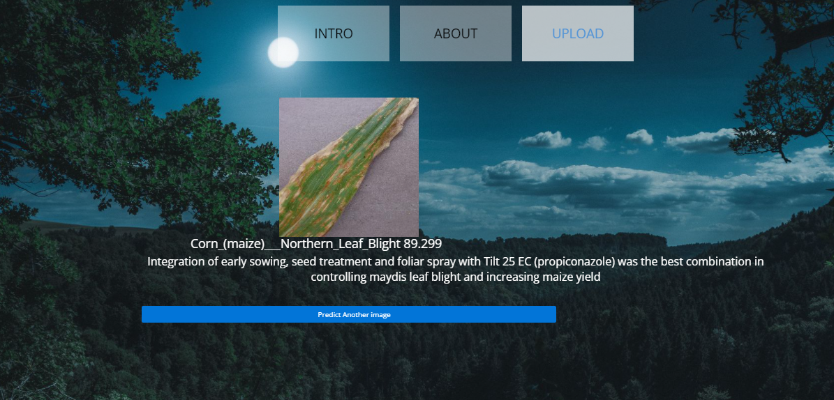

**Fig5**: Classified output

**Classified output:**

The uploaded image is classified as the Potato___Early_blight.

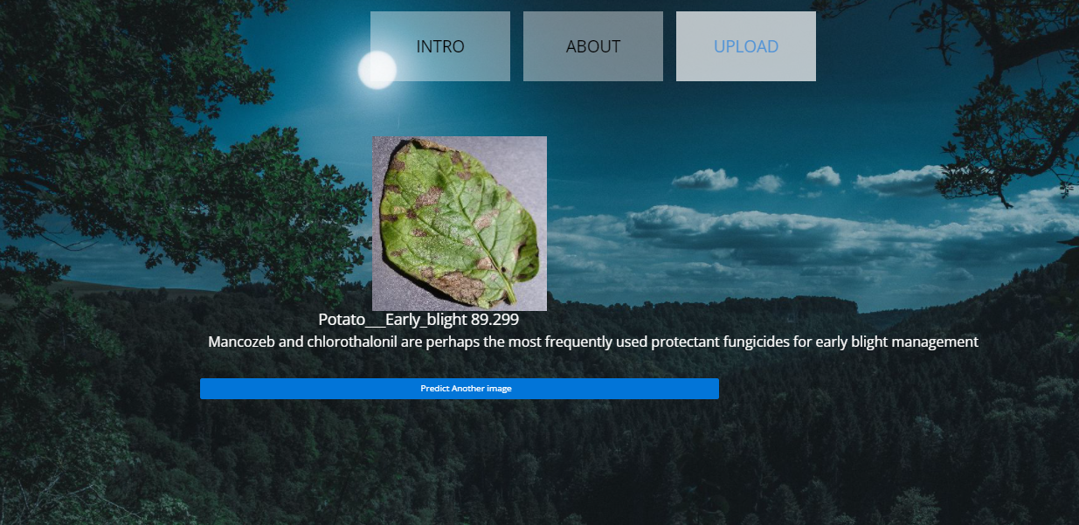

**Fig5**: Classified output

**Classified output:**

The uploaded image is classified as the Potato___healthy.

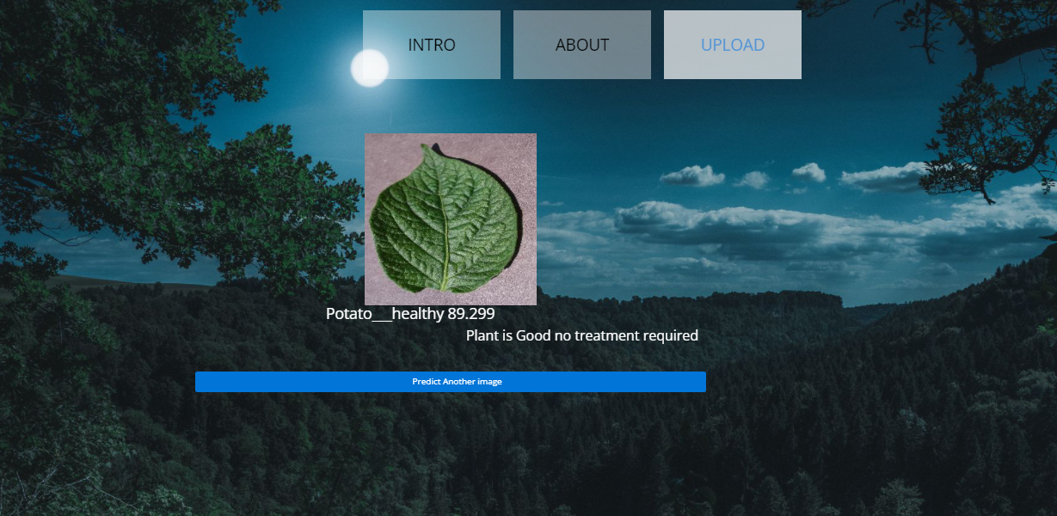

**Fig5**: Classified output

**Classified output:**

The uploaded image is classified as the Potato___Late_blight.

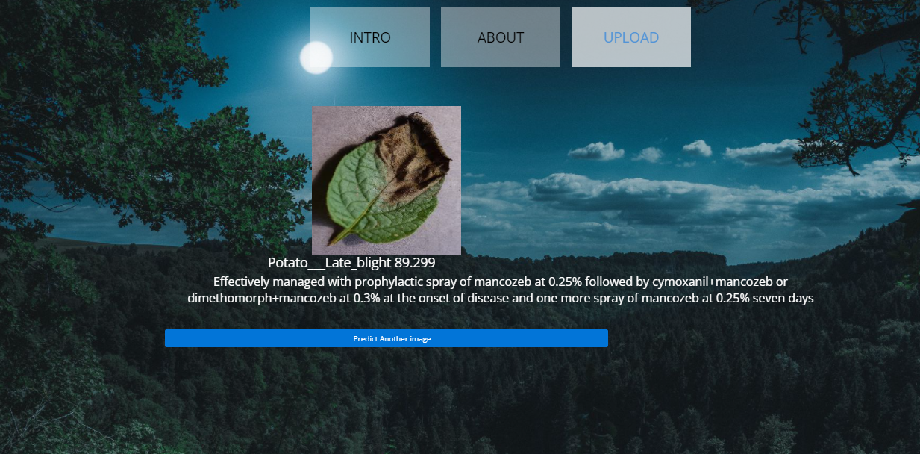

**Fig5**: Classified output

**Classified output:**

The uploaded image is classified as the Tomato___Bacterial_spot.

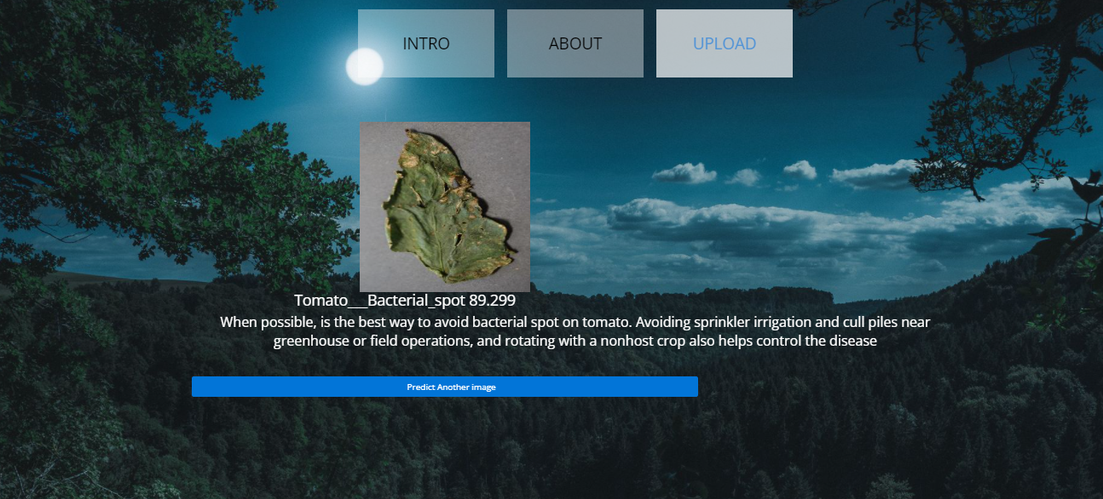

**Fig5**: Classified output

**Classified output:**

The uploaded image is classified as the Tomato___healthy.

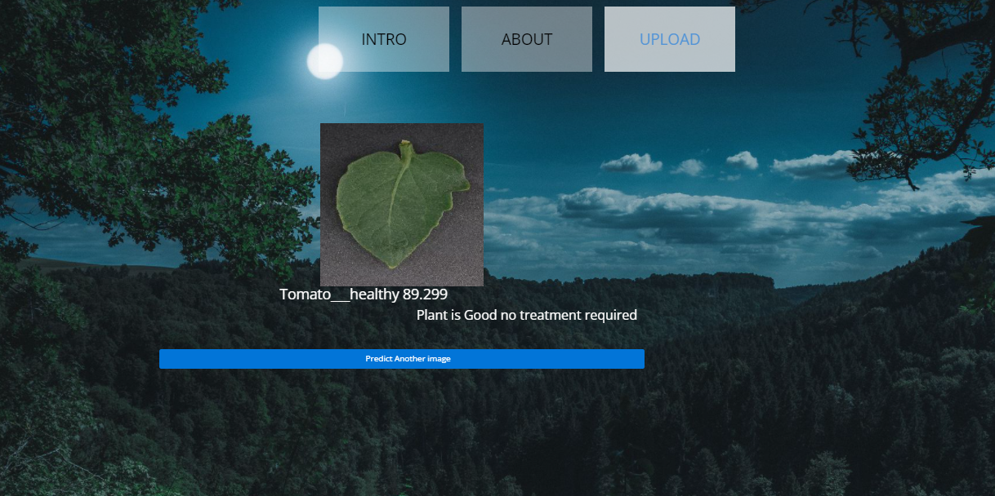

**Fig5**: Classified output

**Classified output:**

The uploaded image is classified as the Tomato___Late_blight.

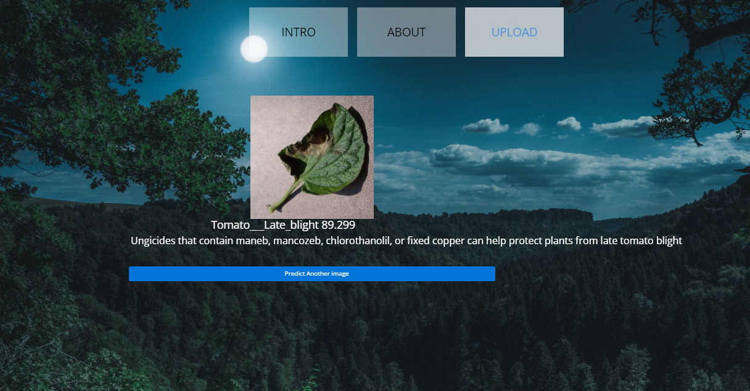

**Fig5**: Classified output

**Classified output:**

The uploaded image is classified as the Tomato___Tomato_Yellow_Leaf_Curl_Virus.

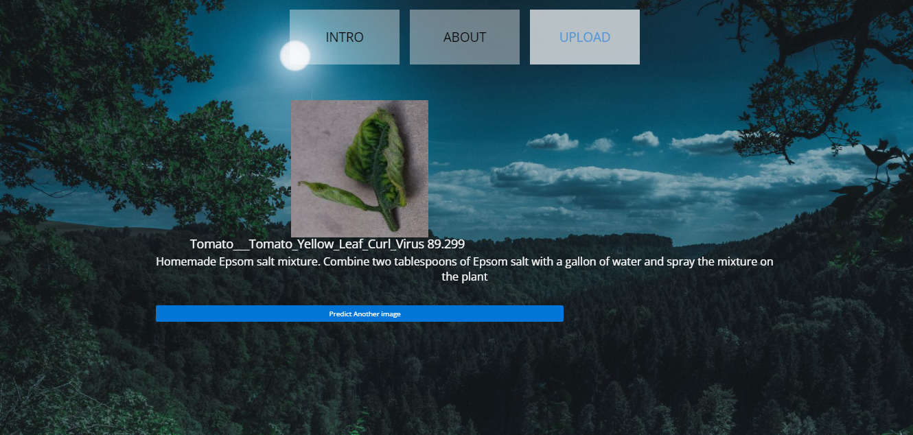

**Fig5**: Classified output

**TEST CASES:**

|  |  |  |
| --- | --- | --- |
| **Input** | **Output** | **Result** |
| Input text | Tested for the classification of Plant Disease Classification | Success |

**TEST CASES MODEL BUILDING:**

|  |  |  |  |  |  |
| --- | --- | --- | --- | --- | --- |
| **S.NO** | **Test cases** | **I/O** | **Expected O/T** | **Actual O/T** | **P/F** |
| 1 | Read the dataset. | Dataset path. | Dataset need to read successfully. | Dataset fetched successfully. | P |
| 2 | Performing pre-processing on the dataset | Pre-processing part takes place | Pre-processing should be performed on dataset | Pre-processing successfully completed. | P |
| 3 | Model Building | Model Building for the clean data | Need to create model using required algorithms | Model Created Successfully. | P |
| 4 | Classification | Input image provided. | Output should be the Identification of Plant Disease Classification | Model classified successfully | P |

**CONCLUSION:**

In this project we have successfully classified the images of Identification of Plant Leaf Diseases Classification, are either affected with the Plant Leaf diseases using the deep learning and machine learning. Here, we have considered the dataset of Plant Leaf Diseases Classification images which will be of different types and different plants (healthy or unhealthy) and trained using SVC, CNN, ANN along with some Resnet50 transfer learning method. After the training we have tested by uploading the image and classified it.

**FUTURE SCOPE:**

This can be utilized in future to classify the types of different Diseases easily that which can tend to easy to Predicated the treatment for plant in early stages and can take the initial curing of plants and take measures to not affect other plants.

**REFERENCES**

1. V. S. Babu, R. Satheesh Kumar and R. Sunder, "A comparative Study on Disease Detection of Plants Using Machine Learning Techniques", 2021 7 th International Conference on Advanced Computing and Communicating Systems (ICACCS 2021) .
2. Yang Zhang, Chenglong Song and Dongwen Zhang, Deep Learning-Based Object Detection Improvement for Tomato Disease, IEEE, 2020.
3. Jun Sun, Yu Yang, Xiaofei He and Xiaohong Wu, Northern Maize Leaf Blight Detection under Complex Field Environment Based on Deep Learning, IEEE, 2020.
4. Peng Jiang, Yeuhan Chen, Bin Liu, Dongiian He and Chunquan Liang, Real-Time Detection of Apple Leaf Diseases Using Deep Learning Approach Based on Improved Convolutional Neural Networks, IEEE, 2019.
5. Nikita Jadhav, Himali Kasar, Sumita Chandak and Shivani Machha, "Crop Leaf Disease Diagnosis using Convolutional Neural Network", Published 2020 Biology International Journal of Trend in Scientific Research and Development.
6. G. Geetha, S. Samundeswari, Saranya Gangadhara Moorthy, K. Meenakshi and M. Nithya, "Plant Leaf Disease Classification and Detection System Using Machine Learning", December 2020 Journal of Physics Conference Series (ICCPET 2020).
7. M. Francis and C. Deisy, "Disease Detection and Classification in Agricultural Plants Using Convolutional Neural Networks", A Visual Understanding Computer Science 2019 6 th International Conference on Signal Processing and Integrated Networks (SPIN) , 2019.
8. S. Hari, M. Siva Kumar, P. Renuga, S. Karthikeyan and S. Suriya, "Detection of Plant Disease by Leaf Image Using Convolutional Neural Network", Computer Science 2019 International Conference on Vision Towards Emerging Trends in Communication and Networking (ViTECoN) 2019.
9. Md Rahmat Ullah, Nagifa Anjum and Abdus Sattar, "Plant Disease Recognition Using Machine Learning", 2019 8 th International Conference System Modeling and Advancement in Research Trenda (SMART 2019) .
10. Melike Sardogan, Adem Tuncer and Yunnus Ozen, "Plant Leaf Disease Detection and Classification Based on CNN with LVQ Algorithm", 3 rd International Conference on Computer Science and Engineering (UBMK) Posted , 2018.
11. Shima Ramesh Maniyath, P V Vinod, M Niveditha, P. R, P. N, N Shashank, et al., "Plant Disease Detection Using Machine Learning", 2018 International Conference on Design Innovations for 3C's Compute Communicate Control (ICDI3C).
12. P. Maheswari, P. Raja and N. M. Ghangoankar, "Intelligent Disease Detection System for Early Blight of Tomato Using Foldscope: A Pilot Study", 2018 IEEE 4th International Symposium in Robotics and Manufacturing Automation (ROMA).
13. Yow-Wen Tian, Peng-Hui Zheng and Rui-Yao Shi, "The Detection System for Greenhouse Tomato Disease Degree Based on Android Platform", 3 rd International Conference on Information Science and Control Engineering Posted , 2016.
14. C Ravi, Jibu Shinde, C Mathew and C Y Patil, "Segmentation Technique for Soybean Leaves Disease Detection", International Journal of Advanced Research, vol. 3, no. 5, 2015.
15. M Ramakrishna, A Sahaya and Anselin Nisha, "Groundnut Leaf Disease Detection and Classification by using Nack Propagation Algorithm", IEEE International Conference, 2015.
16. U. Mokhtar, Mona A. S. Ali, Aboul Ella Hassenian and H. Hefny, "Tomato Leaves Diseases Detection Approach Based on Support Vector Machines", 2015 11 th International Computer Engineering Conference (ICENCO 2015)

**REFERENCES:**

[1] A. Camargo and J.S. Smith, “An image-processing based algorithm to automatically identify plant disease visual symptoms,” Biosystems Engineering, vol.102, pp.9–21, January 2009.

[2] J.S. Cope, D. Corney, J.Y. Clark, P. Remagnino, and P. Wilkin, “Plant species identification using digital morphometrics: A review,” Expert Systems with Applications, vol.39, pp.7562–7573, June 2012.

[3] J. Garcia and A. Barbedo, “Using digital image processing for counting whiteflies on soybean leaves,” Journal of Asia-Pacific Entomology, vol.17, pp.685–694, December 2014.

[4] A. Gongal, S. Amatya, M. Karkee, Q. Zhang, and K. Lewis, “Sensors and systems for fruit detection and localization: A review,” Computers and Electronics in Agriculture, vol.116, pp.8–19, August 2015.

[5] I. Goodfellow, Y. Bengio, and A. Courville, Deep Learning, MIT Press, 2016.

[6] J. Hemming and T. Rath, “Computer-vision-based weed identification under field conditions using controlled lighting,” Journal of Agricultural Engineering Research, vol.78, no.3, pp.233–243, March 2001

[7] S. Ji-Yong, Z. Xiao-Bo, Z. Jie-Wen, W. Kai-Liang, C. Zheng-Wei et al., “Nondestructive diagnostic of nitrogen deficiency by cucumber leaf chlorophyll distribution map based on near infrared hyperspectral imaging,” Scientia Horticulturae, vol.138, pp.190–197, May 2012.

[8] A. Krizhevsky, I. Sutskever, and G. E. Hinton, “Imagenet classification with deep convolutional neural networks,” Proceedings of 25th Advances in Neural Information Processing Systems (NIPS 2012), pp. 1097–1105,2012.

[9] C. Leksomboon, Plant Disease and Diagnosis, Kasetsart University Press, 2011 (in Thai).

[10] P. Li, S.H. Lee, and H.Y. Hsu “Review on fruit harvesting method for potential use of automatic fruit harvesting systems,” Procedia Engineering, vol.23, pp.351–366, 2011.

[11] T. Liu, W. Chen, W. Wu, C. Sun, W. Guo, and X. Zhu, “Detection of aphids in wheat fields using a computer vision technique,” Biosystems Engineering, vol.141, pp.82–93, January 2016.

[12] P. Noinongyao, U. Watchareeruetai, P. Khantiviriya, C. Wattanapaiboonsuk, and S. Duangsrisai, “Separation of abnormal regions on black gram leaves using image analysis,” Proceedings of the 2017 14th International Joint Conference on Computer Science and Software Engineering (JCSSE 2017), 2017.

[13] L.M. Romualdo, P.H.C. Luz, F.F.S. Devechio, M.A. Marin, A.M.G. Zu´niga, O.M. Bruno, and V.R. Herling, “Use of artificial vision tech- ˜ niques for diagnostic of nitrogen nutritional status in maize plants,” Computers and Electronics in Agriculture, vol.104, pp.63–70, June 2014.

[14] S. Sankaran, A. Mishra, R. Ehsani, and C. Davis, “A review of advanced techniques for detecting plant diseases,” Computers and Electronics in Agriculture, vol.72, pp.1–13, June 2010.

[15] Y. Song, C.A. Glasbey, G.W. Horgan, G. Polder, J.A., Deleman, G.W.A.M. van der Heijden, “Automatic fruit recognition and counting from multiple images,” Biosystems Engineering, vol.118, pp.203–215, February 2014.

**BIBLIOGRAPHY:**

**SOFTWARE INSTALLATION FOR MACHINE LEARNING PROJECTS:**

**Installing Python:**

1. To download and install Python visit the official website of Python <https://www.python.org/downloads/> and choose your version.

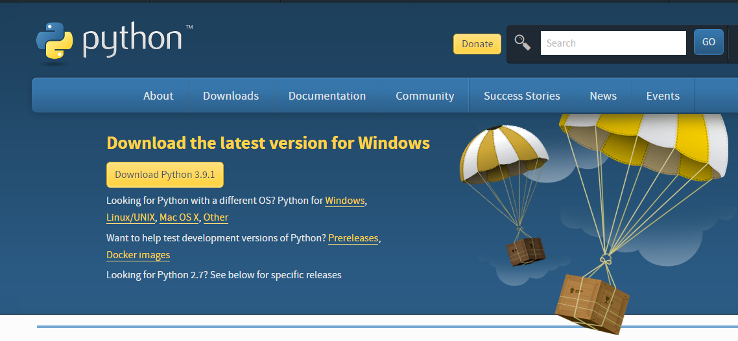

1. Once the download is complete, run the exe for install Python. Now click on Install Now.
2. You can see Python installing at this point.
3. When it finishes, you can see a screen that says the Setup was successful. Now click on "Close".

**Installing PyCharm:**

1. To download PyCharm visit the website <https://www.jetbrains.com/pycharm/download/> and click the "DOWNLOAD" link under the Community Section.



1. Once the download is complete, run the exe for install PyCharm. The setup wizard should have started. Click “Next”.
2. On the next screen, Change the installation path if required. Click “Next”.
3. On the next screen, you can create a desktop shortcut if you want and click on “Next”.
4. Choose the start menu folder. Keep selected Jet Brains and click on “Install”.
5. Wait for the installation to finish.
6. Once installation finished, you should receive a message screen that PyCharm is installed. If you want to go ahead and run it, click the “Run PyCharm Community Edition” box first and click “Finish”.
7. After you click on "Finish," the Following screen will appear.

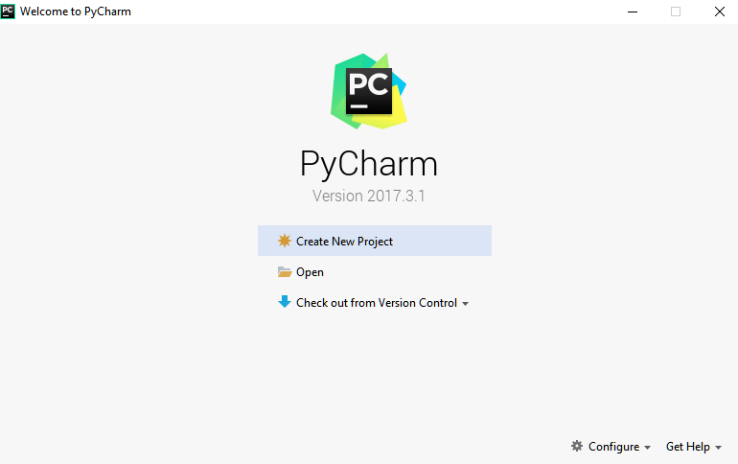

9. You need to install some packages to execute your project in a proper way.

10. Open the command prompt/ anaconda prompt or terminal as administrator.

11. The prompt will get open, with specified path, type “pip install package name” which you want to install (like NumPy, pandas, sea born, scikit-learn, Matplotlib, Pyplot)

Ex: Pip install NumPy

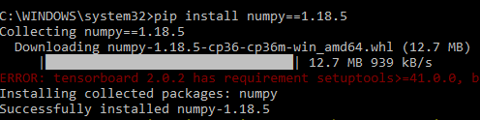

# **INTRODUCTION TO PYTHON**

* Python

### What Is a Script?

Up to this point, I have concentrated on the interactive programming capability of Python.  This is a very useful capability that allows you to type in a program and to have it executed immediately in an interactive mode

Scripts are reusable

Basically, a script is a text file containing the statements that comprise a Python program.  Once you have created the script, you can execute it over and over without having to retype it each time.

Scripts are editable

Perhaps, more importantly, you can make different versions of the script by modifying the statements from one file to the next using a text editor.  Then you can execute each of the individual versions.  In this way, it is easy to create different programs with a minimum amount of typing.

You will need a text editor

Just about any text editor will suffice for creating Python script files.

You can use *Microsoft Notepad, Microsoft WordPad, Microsoft Word,*or just about any word processor if you want to.

Difference between a script and a program

Script:

Scripts are distinct from the core code of the application, which is usually written in a different language, and are often created or at least modified by the end-user. Scripts are often interpreted from source code or byte code, whereas the applications they control are traditionally compiled to native machine code.

Program:

The program has an executable form that the computer can use directly to execute the instructions.

The same program in its human-readable source code form, from which executable programs are derived (e.g., compiled)

Python

What is Python? Chances you are asking yourself this. You may have found this book because you want to learn to program but don’t know anything about programming languages. Or you may have heard of programming languages like C, C++, C#, or Java and want to know what Python is and how it compares to “big name” languages. Hopefully I can explain it for you.

Python concepts

If you’re not interested in the how’s and whys of Python, feel free to skip to the next chapter. In this chapter I will try to explain to the reader why I think Python is one of the best languages available and why it’s a great one to start programming with.

• Open-source general-purpose language.

• Object Oriented, Procedural, Functional

• Easy to interface with C/ObjC/Java/Fortran

• Easy-is to interface with C++ (via SWIG)

• Great interactive environment

• Great interactive environment

Python is a high-level, interpreted, interactive and object-oriented scripting language. Python is designed to be highly readable. It uses English keywords frequently where as other languages use punctuation, and it has fewer syntactical constructions than other languages.

* Python is Interpreted − Python is processed at runtime by the interpreter. You do not need to compile your program before executing it. This is similar to PERL and PHP.
* Python is Interactive − you can actually sit at a Python prompt and interact with the interpreter directly to write your programs.
* Python is Object-Oriented − Python supports Object-Oriented style or technique of programming that encapsulates code within objects.
* Python is a Beginner's Language − Python is a great language for the beginner-level programmers and supports the development of a wide range of applications from simple text processing to WWW browsers to games.

History of Python

Python was developed by Guido van Possum in the late eighties and early nineties at the National Research Institute for Mathematics and Computer Science in the Netherlands.

Python is derived from many other languages, including ABC, Modula-3, C, C++, Algol-68, Smalltalk, and UNIX shell and other scripting languages.

Python is copyrighted. Like Perl, Python source code is now available under the GNU General Public License (GPL).

Python is now maintained by a core development team at the institute, although Guido van Possum still holds a vital role in directing its progress.

Python Features

Python's features include −

* Easy-to-learn − Python has few keywords, simple structure, and a clearly defined syntax. This allows the student to pick up the language quickly.
* Easy-to-read − Python code is more clearly defined and visible to the eyes.
* Easy-to-maintain − Python's source code is fairly easy-to-maintained.
* A broad standard library − Python's bulk of the library is very portable and cross-platform compatible on UNIX, Windows, and Macintosh.
* Interactive Mode − Python has support for an interactive mode which allows interactive testing and debugging of snippets of code.
* Portable − Python can run on a wide variety of hardware platforms and has the same interface on all platforms.
* Extendable − you can add low-level modules to the Python interpreter. These modules enable programmers to add to or customize their tools to be more efficient.
* Databases − Python provides interfaces to all major commercial databases.
* GUI Programming − Python supports GUI applications that can be created and ported to many system calls, libraries and windows systems, such as Windows MFC, Macintosh, and the X Window system of Unix.
* Scalable − Python provides a better structure and support for large programs than shell scripting.

Apart from the above-mentioned features, Python has a big list of good features, few are listed below −

* It supports functional and structured programming methods as well as OOP.
* It can be used as a scripting language or can be compiled to byte-code for building large applications.
* It provides very high-level dynamic data types and supports dynamic type checking.
* IT supports automatic garbage collection.
* It can be easily integrated with C, C++, COM, ActiveX, CORBA, and Java.

Dynamic vs. Static

Types Python is a dynamic-typed language. Many other languages are static typed, such as C/C++ and Java. A static typed language requires the programmer to explicitly tell the computer what type of “thing” each data value is.

For example, in C if you had a variable that was to contain the price of something, you would have to declare the variable as a “float” type.

This tells the compiler that the only data that can be used for that variable must be a floating point number, i.e. a number with a decimal point.

If any other data value was assigned to that variable, the compiler would give an error when trying to compile the program.

Python, however, doesn’t require this. You simply give your variables names and assign values to them. The interpreter takes care of keeping track of what kinds of objects your program is using. This also means that you can change the size of the values as you develop the program. Say you have another decimal number (a.k.a. a floating point number) you need in your program.

With a static typed language, you have to decide the memory size the variable can take when you first initialize that variable. A double is a floating point value that can handle a much larger number than a normal float (the actual memory sizes depend on the operating environment).

If you declare a variable to be a float but later on assign a value that is too big to it, your program will fail; you will have to go back and change that variable to be a double.

With Python, it doesn’t matter. You simply give it whatever number you want and Python will take care of manipulating it as needed. It even works for derived values.

For example, say you are dividing two numbers. One is a floating point number and one is an integer. Python realizes that it’s more accurate to keep track of decimals so it automatically calculates the result as a floating point number

Variables

Variables are nothing but reserved memory locations to store values. This means that when you create a variable you reserve some space in memory.

Based on the data type of a variable, the interpreter allocates memory and decides what can be stored in the reserved memory. Therefore, by assigning different data types to variables, you can store integers, decimals or characters in these variables.

Standard Data Types

The data stored in memory can be of many types. For example, a person's age is stored as a numeric value and his or her address is stored as alphanumeric characters. Python has various standard data types that are used to define the operations possible on them and the storage method for each of them.

Python has five standard data types −

* Numbers
* String
* List
* Tuple
* Dictionary

## Python Numbers

Number data types store numeric values. Number objects are created when you assign a value to them

## Python Strings

Strings in Python are identified as a contiguous set of characters represented in the quotation marks. Python allows for either pairs of single or double quotes. Subsets of strings can be taken using the slice operator ([ ] and [:]) with indexes starting at 0 in the beginning of the string and working their way from -1 at the end.

## Python Lists

Lists are the most versatile of Python's compound data types. A list contains items separated by commas and enclosed within square brackets ([]). To some extent, lists are similar to arrays in C. One difference between them is that all the items belonging to a list can be of different data type.

The values stored in a list can be accessed using the slice operator ([ ] and [:]) with indexes starting at 0 in the beginning of the list and working their way to end -1. The plus (+) sign is the list concatenation operator, and the asterisk (*) is the repetition operator.

## Python Tuples

A tuple is another sequence data type that is similar to the list. A tuple consists of a number of values separated by commas. Unlike lists, however, tuples are enclosed within parentheses.

The main differences between lists and tuples are: Lists are enclosed in brackets ([ ]) and their elements and size can be changed, while tuples are enclosed in parentheses (( )) and cannot be updated. Tuples can be thought of as read-only lists.

## Python Dictionary

Python's dictionaries are kind of hash table type. They work like associative arrays or hashes found in Perl and consist of key-value pairs. A dictionary key can be almost any Python type, but are usually numbers or strings. Values, on the other hand, can be any arbitrary Python object.

Dictionaries are enclosed by curly braces ({ }) and values can be assigned and accessed using square braces ([]).

Different modes in python

Python has two basic modes: normal and interactive.

The normal mode is the mode where the scripted and finished .pie files are run in the Python interpreter.

Interactive mode is a command line shell which gives immediate feedback for each statement, while running previously fed statements in active memory. As new lines are fed into the interpreter, the fed program is evaluated both in part and in whole

# 20 Python libraries

1. Requests. The most famous http library written by Kenneth remits. It’s a must have for every python developer.

2. Scrappy. If you are involved in web scraping then this is a must have library for you. After using this library you won’t use any other.

3. Python. A guy toolkit for python. I have primarily used it in place of tinder. You will really love it.

4. Pillow. A friendly fork of PIL (Python Imaging Library). It is more user friendly than PIL and is a must have for anyone who works with images.

5. SQL Alchemy. A database library. Many love it and many hate it. The choice is yours.

6. Beautiful Soup. I know it’s slow but this xml and html parsing library is very useful for beginners.

7. Twisted. The most important tool for any network application developer. It has a very beautiful ape and is used by a lot of famous python developers.

8. Numbly. How can we leave this very important library? It provides some advance math functionalities to python.

9. Skippy. When we talk about numbly then we have to talk about spicy. It is a library of algorithms and mathematical tools for python and has caused many scientists to switch from ruby to python.

10. Matplotlib. A numerical plotting library. It is very useful for any data scientist or any data analyzer.

11. Pygmy. Which developer does not like to play games and develop them? This library will help you achieve your goal of 2d game development.

12. Piglet. A 3d animation and game creation engine. This is the engine in which the famous [python port](https://github.com/fogleman/Minecraft) of mine craft was made

13. Pit. A GUI toolkit for python. It is my second choice after python for developing GUI’s for my python scripts.

14. Pit. Another python GUI library. It is the same library in which the famous Bit torrent client is created.

15. Scaly. A packet sniffer and analyzer for python made in python.

16. Pywin32. A python library which provides some useful methods and classes for interacting with windows.

17. Notch. Natural Language Toolkit – I realize most people won’t be using this one, but it’s generic enough. It is a very useful library if you want to manipulate strings. But its capacity is beyond that. Do check it out.

18. Nose. A testing framework for python. It is used by millions of python developers. It is a must have if you do test driven development.

19. Simply. Simply can do algebraic evaluation, differentiation, expansion, complex numbers, etc. It is contained in a pure Python distribution.

20. I Python. I just can’t stress enough how useful this tool is. It is a python prompt on steroids. It has completion, history, shell capabilities, and a lot more. Make sure that you take a look at it.

Numpy

Humpy’s main object is the homogeneous multidimensional array. It is a table of elements (usually numbers), all of the same type, indexed by a tuple of positive integers. In numbly dimensions are called axes. The number of axes is rank.

• Offers Matlab-ish capabilities within Python

• Fast array operations

• 2D arrays, multi-D arrays, linear algebra etc.

Matplotlib

• High quality plotting library.

Python class and objects

These are the building blocks of OOP. Class creates a new object. This object can be anything, whether an abstract data concept or a model of a physical object, e.g. a chair. Each class has individual characteristics unique to that class, including variables and methods. Classes are very powerful and currently “the big thing” in most programming languages. Hence, there are several chapters dedicated to OOP later in the book.

The class is the most basic component of object-oriented programming. Previously, you learned how to use functions to make your program do something.

Now will move into the big, scary world of Object-Oriented Programming (OOP). To be honest, it took me several months to get a handle on objects.

When I first learned C and C++, I did great; functions just made sense for me.

Having messed around with BASIC in the early ’90s, I realized functions were just like subroutines so there wasn’t much new to learn.

However, when my C++ course started talking about objects, classes, and all the new features of OOP, my grades definitely suffered.

Once you learn OOP, you’ll realize that it’s actually a pretty powerful tool. Plus many Python libraries and APIs use classes, so you should at least be able to understand what the code is doing.

One thing to note about Python and OOP: it’s not mandatory to use objects in your code in a way that works best; maybe you don’t need to have a full-blown class with initialization code and methods to just return a calculation. With Python, you can get as technical as you want.

As you’ve already seen, Python can do just fine with functions. Unlike languages such as Java, you aren’t tied down to a single way of doing things; you can mix functions and classes as necessary in the same program. This lets you build the code

Objects are an encapsulation of variables and functions into a single entity. Objects get their variables and functions from classes. Classes are essentially a template to create your objects.

Here’s a brief list of Python OOP ideas:

• The class statement creates a class object and gives it a name. This creates a new namespace.

• Assignments within the class create class attributes. These attributes are accessed by qualifying the name using dot syntax: ClassName.Attribute.

• Class attributes export the state of an object and its associated behavior. These attributes are shared by all instances of a class.

• Calling a class (just like a function) creates a new instance of the class.

This is where the multiple copies part comes in.

• Each instance gets ("inherits") the default class attributes and gets its own namespace. This prevents instance objects from overlapping and confusing the program.

• Using the term self identifies a particular instance, allowing for per-instance attributes. This allows items such as variables to be associated with a particular instance.

Inheritance

First off, classes allow you to modify a program without really making changes to it.

To elaborate, by sub classing a class, you can change the behaviour of the program by simply adding new components to it rather than rewriting the existing components.

As we’ve seen, an instance of a class inherits the attributes of that class.

However, classes can also inherit attributes from other classes. Hence, a subclass inherits from a superclass allowing you to make a generic superclass that is specialized via subclasses.

The subclasses can override the logic in a superclass, allowing you to change the behavior of your classes without changing the superclass at all.

Operator Overloads

Operator overloading simply means that objects that you create from classes can respond to actions (operations) that are already defined within Python, such as addition, slicing, printing, etc.

Even though these actions can be implemented via class methods, using overloading ties the behavior closer to Python’s object model and the object interfaces are more consistent to Python’s built-in objects, hence overloading is easier to learn and use.

User-made classes can override nearly all of Python’s built-in operation methods

Exceptions

I’ve talked about exceptions before but now I will talk about them in depth. Essentially, exceptions are events that modify program’s flow, either intentionally or due to errors.

They are special events that can occur due to an error, e.g. trying to open a file that doesn’t exist, or when the program reaches a marker, such as the completion of a loop.

Exceptions, by definition, don’t occur very often; hence, they are the "exception to the rule" and a special class has been created for them. Exceptions are everywhere in Python.

Virtually every module in the standard Python library uses them, and Python itself will raise them in a lot of different circumstances.

Here are just a few examples:

• Accessing a non−existent dictionary key will raise a Key Error exception.

• Searching a list for a non−existent value will raise a Value Error exception

. • Calling a non−existent method will raise an Attribute Error exception.

• Referencing a non−existent variable will raise a Name Error exception.

• Mixing data types without coercion will raise a Type Error exception.

One use of exceptions is to catch a fault and allow the program to continue working; we have seen this before when we talked about files.

This is the most common way to use exceptions. When programming with the Python command line interpreter, you don’t need to worry about catching exceptions.

Your program is usually short enough to not be hurt too much if an exception occurs.

Plus, having the exception occur at the command line is a quick and easy way to tell if your code logic has a problem.

However, if the same error occurred in your real program, it will fail and stop working. Exceptions can be created manually in the code by raising an exception.

It operates exactly as a system-caused exceptions, except that the programmer is doing it on purpose. This can be for a number of reasons. One of the benefits of using exceptions is that, by their nature, they don’t put any overhead on the code processing.

Because exceptions aren’t supposed to happen very often, they aren’t processed until they occur.

Exceptions can be thought of as a special form of the if/elf statements. You can realistically do the same thing with if blocks as you can with exceptions.

However, as already mentioned, exceptions aren’t processed until they occur; if blocks are processed all the time.

Proper use of exceptions can help the performance of your program.

The more infrequent the error might occur, the better off you are to use exceptions; using if blocks requires Python to always test extra conditions before continuing.

Exceptions also make code management easier: if your programming logic is mixed in with error-handling if statements, it can be difficult to read, modify, and debug your program.

User-Defined Exceptions

I won’t spend too much time talking about this, but Python does allow for a programmer to create his own exceptions.

You probably won’t have to do this very often but it’s nice to have the option when necessary.

However, before making your own exceptions, make sure there isn’t one of the built-in exceptions that will work for you.

They have been "tested by fire" over the years and not only work effectively, they have been optimized for performance and are bug-free.

Making your own exceptions involves object-oriented programming, which will be covered in the next chapter

. To make a custom exception, the programmer determines which base exception to use as the class to inherit from, e.g. making an exception for negative numbers or one for imaginary numbers would probably fall under the Arithmetic Error exception class.

To make a custom exception, simply inherit the base exception and define what it will do.

Python modules

Python allows us to store our code in files (also called modules). This is very useful for more serious programming, where we do not want to retype a long function definition from the very beginning just to change one mistake. In doing this, we are essentially defining our own modules, just like the modules defined already in the Python library.

To support this, Python has a way to put definitions in a file and use them in a script or in an interactive instance of the interpreter. Such a file is called a module; definitions from a module can be imported into other modules or into the main module.

Testing code

As indicated above, code is usually developed in a file using an editor.

To test the code, import it into a Python session and try to run it.

Usually there is an error, so you go back to the file, make a correction, and test again.

This process is repeated until you are satisfied that the code works. T

His entire process is known as the development cycle.

There are two types of errors that you will encounter. Syntax errors occur when the form of some command is invalid.

This happens when you make typing errors such as misspellings, or call something by the wrong name, and for many other reasons. Python will always give an error message for a syntax error.

Functions in Python

It is possible, and very useful, to define our own functions in Python. Generally speaking, if you need to do a calculation only once, then use the interpreter. But when you or others have need to perform a certain type of calculation many times, then define a function.

You use functions in programming to bundle a set of instructions that you want to use repeatedly or that, because of their complexity, are better self-contained in a sub-program and called when needed. That means that a function is a piece of code written to carry out a specified task.

## To carry out that specific task, the function might or might not need multiple inputs. When the task is carved out, the function can or cannot return one or more values.

## There are three types of functions in python:

## Help (), min (), print ().

Namespaces in Python are implemented as Python dictionaries, this means it is a mapping from names (keys) to objects (values). The user doesn't have to know this to write a Python program and when using namespaces.

Some namespaces in Python:

* global names of a module
* local names in a function or method invocation
* built-in names: this namespace contains built-in functions (e.g. abs(), camp(), ...) and built-in exception names

Garbage Collection

Garbage Collector exposes the underlying memory management mechanism of Python, the automatic garbage collector. The module includes functions for controlling how the collector operates and to examine the objects known to the system, either pending collection or stuck in reference cycles and unable to be freed.

Python XML Parser

XML is a portable, open source language that allows programmers to develop applications that can be read by other applications, regardless of operating system and/or developmental language.

What is XML? The Extensible Markup Language XML is a markup language much like HTML or SGML.

This is recommended by the World Wide Web Consortium and available as an open standard.

XML is extremely useful for keeping track of small to medium amounts of data without requiring a SQL-based backbone.

XML Parser Architectures and APIs the Python standard library provides a minimal but useful set of interfaces to work with XML.

The two most basic and broadly used APIs to XML data are the SAX and DOM interfaces.

Simple API for XML SAX: Here, you register call-backs for events of interest and then let the parser proceed through the document.

This is useful when your documents are large or you have memory limitations, it parses the file as it reads it from disk and the entire file is never stored in memory.

Document Object Model DOM API : This is a World Wide Web Consortium recommendation wherein the entire file is read into memory and stored in a hierarchical tree − based form to represent all the features of an XML document.

SAX obviously cannot process information as fast as DOM can when working with large files. On the other hand, using DOM exclusively can really kill your resources, especially if used on a lot of small files.

SAX is read-only, while DOM allows changes to the XML file. Since these two different APIs literally complement each other, there is no reason why you cannot use them both for large projects.

Python Web Frameworks

A web framework is a code library that makes a developer's life easier when building reliable, scalable and maintainable web applications.

## Why are web frameworks useful?

Web frameworks encapsulate what developers have learned over the past twenty years while programming sites and applications for the web. Frameworks make it easier to reuse code for common HTTP operations and to structure projects so other developers with knowledge of the framework can quickly build and maintain the application.

Common web framework functionality

Frameworks provide functionality in their code or through extensions to perform common operations required to run web applications. These common operations include:

1. URL routing
2. HTML, XML, JSON, and other output format tinplating
3. Database manipulation
4. Security against Cross-site request forgery (CSRF) and other attacks
5. Session storage and retrieval

Not all web frameworks include code for all of the above functionality. Frameworks fall on the spectrum from executing a single use case to providing every known web framework feature to every developer. Some frameworks take the "batteries-included" approach where everything possible comes bundled with the framework while others have a minimal core package that is amenable to extensions provided by other packages.

## Comparing web frameworks

There is also a repository called [compare-python-web-frameworks](https://github.com/mattmakai/compare-python-web-frameworks) where the same web application is being coded with varying Python web frameworks, tinplating engines and object.

## Web framework resources

* When you are learning how to use one or more web frameworks it's helpful to have an idea of what the code under the covers is doing.
* Frameworks is a really well done short video that explains how to choose between web frameworks. The author has some particular opinions about what should be in a framework. For the most part I agree although I've found sessions and database ORMs to be a helpful part of a framework when done well.
* What is a web framework? Is an in-depth explanation of what web frameworks are and their relation to web servers?
* Jingo vs. Flash vs. Pyramid: Choosing a Python web framework contains background information and code comparisons for similar web applications built in these three big Python frameworks.
* This fascinating blog post takes a look at the code complexity of several Python web frameworks by providing visualizations based on their code bases.
* Python’s web frameworks benchmarks  is a test of the responsiveness of a framework with encoding an object to JSON and returning it as a response as well as retrieving data from the database and rendering it in a template. There were no conclusive results but the output is fun to read about nonetheless.
* What web frameworks do you use and why are they awesome? Is a language agnostic Reedit discussion on web frameworks? It's interesting to see what programmers in other languages like and dislike about their suite of web frameworks compared to the main Python frameworks.
* This user-voted question & answer site asked "What are the best general purpose Python web frameworks usable in production?” The votes aren't as important as the list of the many frameworks that are available to Python developers.

## Web frameworks learning checklist

1. Choose a major Python web framework (Jingo or Flask are recommended) and stick with it. When you're just starting it's best to learn one framework first instead of bouncing around trying to understand every framework.
2. Work through a detailed tutorial found within the resources links on the framework's page.
3. Study open source examples built with your framework of choice so you can take parts of those projects and reuse the code in your application.
4. Build the first simple iteration of your web application then go to the [deployment](https://www.fullstackpython.com/deployment.html) section to make it accessible on the web.

2. SYSTEM STUDY

### SYSTEM TESTING

The purpose of testing is to discover errors. Testing is the process of trying to discover every conceivable fault or weakness in a work product. It provides a way to check the functionality of components, sub-assemblies, assemblies and/or a finished product It is the process of exercising software with the intent of ensuring that the

Software system meets its requirements and user expectations and does not fail in an unacceptable manner. There are various types of test. Each test type addresses a specific testing requirement.

TYPES OF TESTS

Unit testing

Unit testing involves the design of test cases that validate that the internal program logic is functioning properly, and that program inputs produce valid outputs. All decision branches and internal code flow should be validated. It is the testing of individual software units of the application .it is done after the completion of an individual unit before integration. This is a structural testing, that relies on knowledge of its construction and is invasive. Unit tests perform basic tests at component level and test a specific business process, application, and/or system configuration. Unit tests ensure that each unique path of a business process performs accurately to the documented specifications and contains clearly defined inputs and expected results.

Integration testing

Integration tests are designed to test integrated software components to determine if they actually run as one program. Testing is event driven and is more concerned with the basic outcome of screens or fields. Integration tests demonstrate that although the components were individually satisfaction, as shown by successfully unit testing, the combination of components is correct and consistent. Integration testing is specifically aimed at exposing the problems that arise from the combination of components.

Functional test

Functional tests provide systematic demonstrations that functions tested are available as specified by the business and technical requirements, system documentation, and user manuals.

Functional testing is centered on the following items:

Valid Input : identified classes of valid input must be accepted.

Invalid Input : identified classes of invalid input must be rejected.

Functions : identified functions must be exercised.

Output : identified classes of application outputs must be exercised.

Systems/Procedures: interfacing systems or procedures must be invoked.

Organization and preparation of functional tests is focused on requirements, key functions, or special test cases. In addition, systematic coverage pertaining to identify Business process flows; data fields, predefined processes, and successive processes must be considered for testing. Before functional testing is complete, additional tests are identified and the effective value of current tests is determined.

SYSTEM TEST

System testing ensures that the entire integrated software system meets requirements. It tests a configuration to ensure known and predictable results. An example of system testing is the configuration oriented system integration test. System testing is based on process descriptions and flows, emphasizing pre-driven process links and integration points.

White Box Testing

White Box Testing is a testing in which in which the software tester has knowledge of the inner workings, structure and language of the software, or at least its purpose. It is purpose. It is used to test areas that cannot be reached from a black box level.

Black Box Testing

Black Box Testing is testing the software without any knowledge of the inner workings, structure or language of the module being tested. Black box tests, as most other kinds of tests, must be written from a definitive source document, such as specification or requirements document, such as specification or requirements document. It is a testing in which the software under test is treated, as a black box .you cannot “see” into it. The test provides inputs and responds to outputs without considering how the software works.

6.1 Unit Testing:

Unit testing is usually conducted as part of a combined code and unit test phase of the software lifecycle, although it is not uncommon for coding and unit testing to be conducted as two distinct phases.

Test strategy and approach

Field testing will be performed manually and functional tests will be written in detail.

Test objectives

* All field entries must work properly.
* Pages must be activated from the identified link.
* The entry screen, messages and responses must not be delayed.

Features to be tested

* Verify that the entries are of the correct format
* No duplicate entries should be allowed
* All links should take the user to the correct page.

# 6.2 Integration Testing

Software integration testing is the incremental integration testing of two or more integrated software components on a single platform to produce failures caused by interface defects.

The task of the integration test is to check that components or software applications, e.g. components in a software system or – one step up – software applications at the company level – interact without error.

Test Results: All the test cases mentioned above passed successfully. No defects encountered.

6.3 Acceptance Testing

User Acceptance Testing is a critical phase of any project and requires significant participation by the end user. It also ensures that the system meets the functional requirements.

Test Results: All the test cases mentioned above passed successfully. No defects encountered.